**PROJECT PROPOSAL FOR BANK LOAN**

**OF**

**SOLAR POWERED BULK MILK CHILLER**

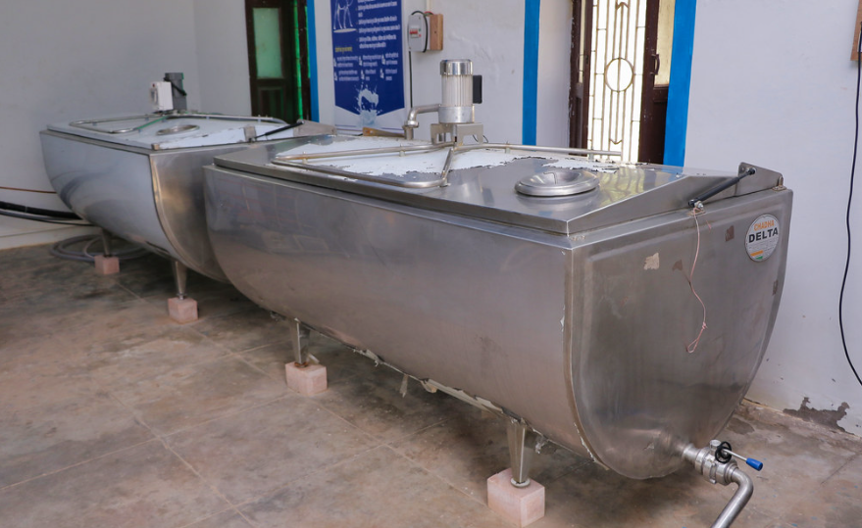

|  |  |
| --- | --- |
| **Sl. No.** | **Contents** |
| 1 | Background of the applicant |
| 2 | Background of the solution |
| 3 | Opportunities |
| 4 | Solution (Technology + Solar) |
| 4.1 | * Solar Technical Design |
| 5 | Business Model |
| 5.1  5.2 | * Customer Details * Revenue Model |
| 5.2 | * Supplier details |
| 6 | Financial Details of the project |
| 6.1 | * Total Project Cost |
| 6.2 | * Contribution Margin |
| 6.3 | * Forecasted Revenue, Expenses, and Profits |
| 6.4 | * Break-even Analysis |
| 6.5 | * Loan Details |
| 6.6 | * Financial ratios |

1. **BACKGROUND OF THE APPLICANT**

________ is from ________. With good market linkage, they are looking to start the **Bulk Milk Chiller** business. Requesting a loan of **Rs. 16,23,000/- for 5 years.**

1. **BACKGROUND OF THE SOLUTION**

A significant number of households rely on dairy farming as a supplementary source of income. However, challenges arise in maintaining milk quality due to lack of proper chilling facilities. Traditional methods often lead to spoilage and reduced shelf life, impacting the income of dairy farmers. Bulk milk chillers are used for collecting milk at community level. With bulk milk chiller, milk cools from 35 C to 4 C. It also ensures that the milk remains within the desired temperature (4degC) till the milk tank arrives for bulk collection. Traditional chilling methods are inefficient and unreliable, resulting in compromised milk quality and financial losses for farmers. By utilizing solar-powered bulk milk chillers, dairy farmers can rapidly cool large quantities of milk to optimal storage temperatures, preserving freshness and extending shelf life. As a result, the adoption of bulk milk chillers not only enhances milk quality but also contributes to increased income and sustainability for rural dairy farming communities.

1. **OPPORTUNITIES**

* Innovative cooling technologies can offer quick milk chilling, improving milk quality and safety standards in remote areas.
* By developing efficient cooling solutions, milk preservation can be optimized, reducing operational costs.
* Shifting to renewable energy sources can lower cooling costs and promote sustainability in milk chilling processes, benefiting both producers and consumers.
* Exploring alternatives to diesel generators can pave the way for cleaner and more cost-effective milk chilling methods, driving positive change in dairy operations.

1. **SOLUTIONS (SOLAR + TECH)**

The solution has a 1.7kW DRE-led Bulk Milk Chiller with a storage capacity of 1000 liters per day. The solutions can be customized and applicable to fixed sellers.

**4.1 Solar Technical Design**

**Load details:**

|  |  |  |  |  |
| --- | --- | --- | --- | --- |
| **S.no** | **Description** | **Load** | **Nos** | **Hours** |
| 1 | Bulk Milk Chiller | 1.7kW | 1 | 6 |
| 2 | LED Light | 10W | 2 | 3 |

**Solar System Bill of Materials:**

|  |  |  |  |
| --- | --- | --- | --- |
| **Sl No.** | **Material** | **Capacity** | **Quantity** |
| 1 | Solar Module | 250 Wp, 24 V | 1 |
| 2 | Solar battery | 180 Ah, 12 V | 1 |
| 3 | Bulk Milk Chiller | 1.7kW | 1 |
| 4 | LED Light | 10 W, 230 Vac. | 2 |

**5. Business Model**

The Bulk Milk Chiller business model aims to address challenges related to inconsistent cooling, ensuring optimal milk preservation and quality. By adopting solar-powered cooling solution, it not only enhances milk quality but also creates economic opportunities for underserved populations.

**5.1 Customer Details**

|  |  |  |  |  |  |
| --- | --- | --- | --- | --- | --- |
| **Sl. No** | **Name of the customer** | **Contact Number** | **Location** | **Roti variety purchased** | **Order Volume** |
|  |  |  |  |  |  |

**5.2 Revenue Model**

|  |  |
| --- | --- |
| **Particulars** | **Details** |
| Customer Segment | * Dairy Farmers * Agricultural Cooperatives * Rural Milk Collection Centres * Dairy Processing Units |
| Products Sold | * Milk |
| Selling Price | * ₹ 50 per Liter |

**5.3 Vendor Details**

|  |  |  |  |  |  |
| --- | --- | --- | --- | --- | --- |
| **Sl. No** | **Name of the vendor** | **Contact Number** | **Location (Address/Region)** | **Distance from the unit (in KMs)** | **Receipts** |
|  |  |  |  |  |  |

1. **FINANCIAL DETAILS OF THE PROJECT**

**Table 6.1: Project Cost**

|  |  |
| --- | --- |
| **Capital Costs** | **Amount (₹)** |
| Machine + Solar Cost | ₹1,623,000 |
| Other Costs | ₹0 |
| **Total Capital Cost** | **₹1,623,000** |

**Table 6.2 Contribution Margin**

|  |  |  |
| --- | --- | --- |
| **Source of Fund** | **Amount** | **Percentage** |
| End User Contribution | ₹0 | 0.00% |
| Gap finance | ₹0 | 0.00% |
| Loan | ₹1,623,000 | 100.00% |
| **Total** | **₹1,623,000** | **100.00%** |

**Table 6.3: Forecasted Revenue, Expenses, and Profit during a year:**

|  |  |  |  |  |  |  |
| --- | --- | --- | --- | --- | --- | --- |
| **Sr. No.** | **Particulars** | **Year 1** | **Year 2** | **Year 3** | **Year 4** | **Year 5** |
| 1 | **Revenue** | | | | | |
| a | Quantity (Liters) | 282,240 | 287,885 | 293,642 | 299,515 | 305,506 |
| b | Selling Price (₹/L) | ₹ 50 | ₹ 50 | ₹ 50 | ₹ 50 | ₹ 50 |
|  | **Total Revenue** | **₹ 14,112,000** | **₹ 14,394,240** | **₹ 14,682,125** | **₹ 14,975,767** | **₹ 15,275,283** |
| 2 | **Expenses** | | | | | |
|  | Human Resource | ₹ 300,000 | ₹ 300,000 | ₹ 300,000 | ₹ 300,000 | ₹ 300,000 |
|  | Rent and Maintenance | ₹ 120,000 | ₹ 120,000 | ₹ 120,000 | ₹ 120,000 | ₹ 120,000 |
|  | Raw Material (Cow Milk) | ₹ 10,368,000 | ₹ 10,368,000 | ₹ 10,368,000 | ₹ 10,368,000 | ₹ 10,368,000 |
|  | Electricity | ₹ 0 | ₹ 0 | ₹ 0 | ₹ 0 | ₹ 0 |
|  | Transport | ₹ 1,411,200 | ₹ 1,411,200 | ₹ 1,411,200 | ₹ 1,411,200 | ₹ 1,411,200 |
|  | Packaging | ₹ 508,032 | ₹ 508,032 | ₹ 508,032 | ₹ 508,032 | ₹ 508,032 |
|  | Other Expenses | ₹ 0 | ₹ 0 | ₹ 0 | ₹ 0 | ₹ 0 |
|  | **Total Expenses** | **₹ 12,707,232** | **₹ 12,707,232** | **₹ 12,707,232** | **₹ 12,707,232** | **₹ 12,707,232** |
| 3 | **Operating Profit/ (Loss) - Before EMI** | **₹ 1,404,768** | **₹ 1,687,008** | **₹ 1,974,893** | **₹ 2,268,535** | **₹ 2,568,051** |
| 4 | EMI | ₹ 433,233 | ₹ 433,233 | ₹ 433,233 | ₹ 433,233 | ₹ 433,233 |
| 5 | **Net Profit / (Loss)** | **₹ 971,535** | **₹ 1,253,775** | **₹ 1,541,660** | **₹ 1,835,302** | **₹ 2,134,818** |

**Table 6.4: Breakeven Analysis**

|  |  |  |  |
| --- | --- | --- | --- |
| **Sr. No.** | **Breakeven Analysis** | **Output (Litres)** | **Revenue (₹)** |
| 1 | At max production (per month) | 30,000.0 | ₹ 1,500,000 |
| 2 | At breakeven | 10,997.6 | ₹ 549,879 |

**Table 6.5: Loan Details**

|  |  |
| --- | --- |
| **Loan Financing** | |
| Loan Amount Taken | ₹1,623,000 |
| Down Payment | ₹0 |
| Interest Rate | 12% |
| No. of Instalments (months) | 60 |
| EMI (per month/instalment) | ₹ 36,103 |
| Loan Repayment | ₹ 2,166,164 |
| Payback Period (months) | 13.33 |

**Table 6.6: Financial Ratios**

|  |  |
| --- | --- |
| **Key Financial Data and Analysis** | |
| ROI per annum | 133.01% |
| NPV | ₹ 7,027,204 |
| IRR | 8.54% |
| Benefit-Cost Ratio (BCR) | 1.16x |